C-DAC Mumbai Date 25/09/2024

Subject: Algorithm and Data Structure
Assignment 1

1. Armstrong Number
Problem: Write a Java program to check if a given number is an Armstrong number.
import java.util.Scanner;
import java.lang.Math;

class Armstrong{
static boolean isArmstrong(int n){
int temp,digits=0,last=0,sum=0;
temp = n;
while(temp>0){
temp = temp/10;
digits++;
}
temp=n;
while(temp>0){
last = temp%10;
sum+=(Math.pow(last,digits));
temp = temp/10;
}
if(n==sum){
return true;
}
else {
return false;
}

}
public static void main(String args[]){
int n1,n2;
Scanner sc = new Scanner(System.in);
n1 = sc.nextInt();
n2 = sc.nextInt();
if(isArmstrong(n1)){
System.out.println(n1 + "is Armstrong");
}else{
System.out.println(n1 + "is not Armstrong");
}
if(isArmstrong(n2)){
System.out.println(n2 + "is Armstrong");
}else{
System.out.println(n2 + "is not Armstrong");
}
}
}

output:C:\Users\saira\OneDrive\Documents\CDAC\ADS Module\Assignment1>java Armstrong
153
123
153 is Armstrong
123 is not Armstrong

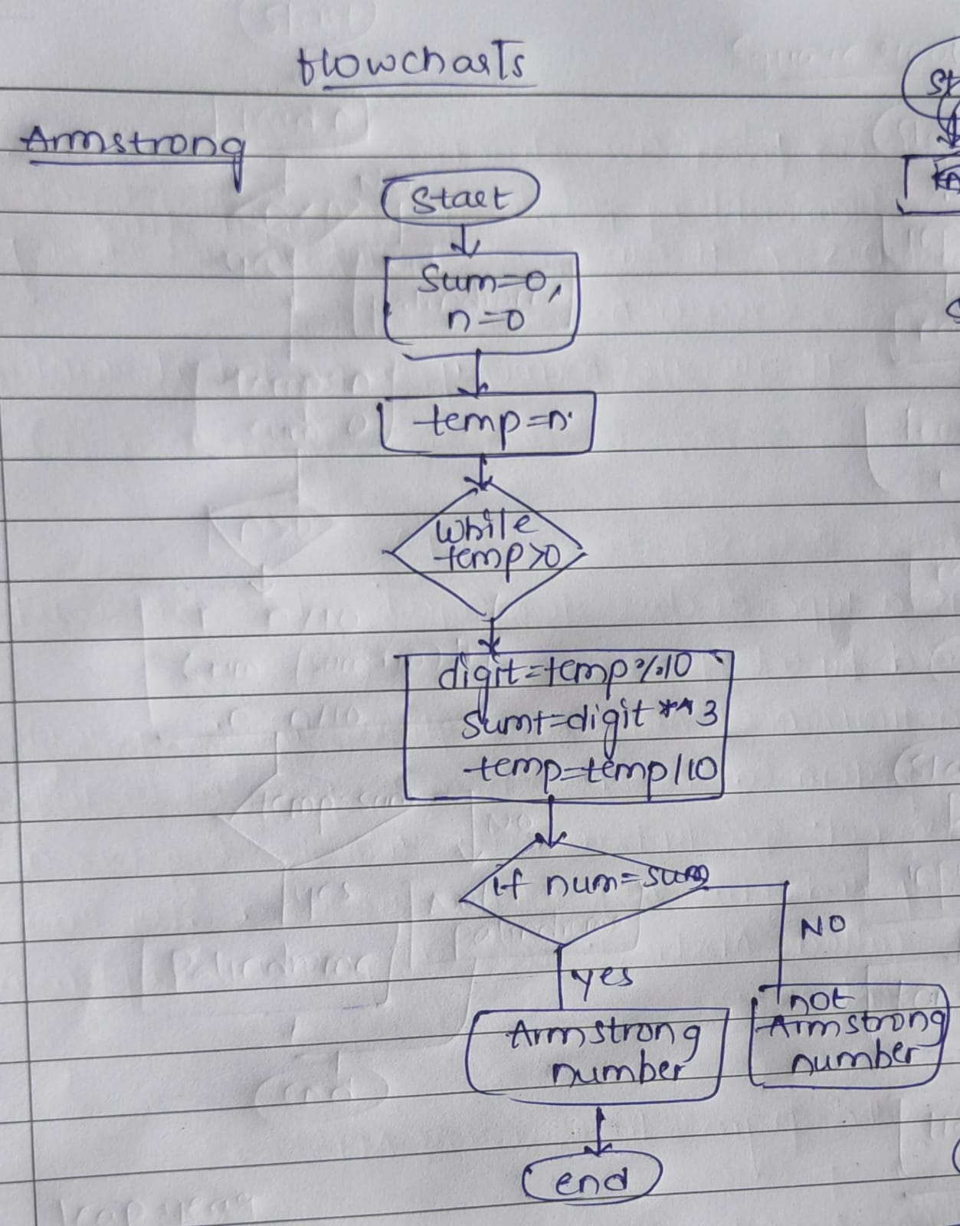
- Time Complexity: O(log⁡ n)
- Space Complexity: O(1)

2. Prime Number
Problem: Write a Java program to check if a given number is prime.
class Prime{
static void isPrime(int n){
int i,m=0,flag=0;
m=n/2;
if(n==0 || n==1){
System.out.println(n + " is not prime number");
}
else{
for(i=2;i<=m;i++){
if(n%i==0){
System.out.println(n +" is not prime number");
flag=1;
break;
}
}
if(flag == 0){
System.out.println(n +" is prime number");
}
}
}
public static void main(String args[]){
isPrime(29);
isPrime(15);
}
}
C:\Users\saira\OneDrive\Documents\CDAC\ADS Module\Assignment1>java Prime
29 is prime number
15 is not prime number

Time Complexity: O(n)
Space Complexity: O(1)
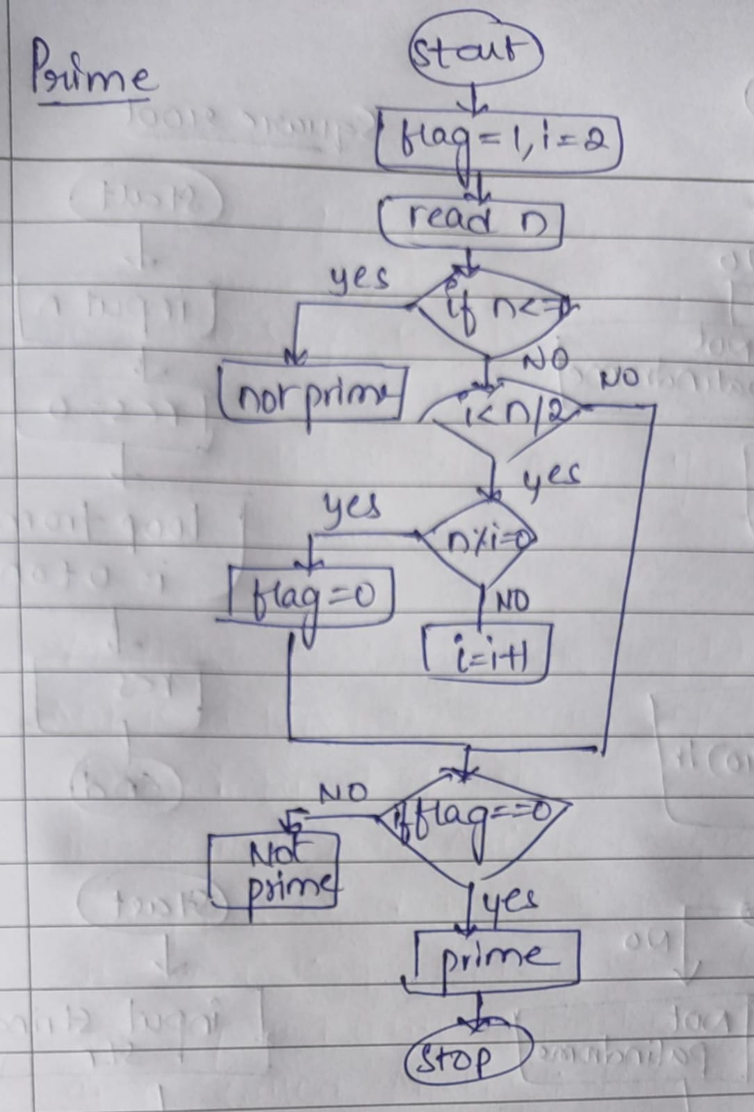
3. Factorial
Problem: Write a Java program to compute the factorial of a given number.
import java.util.Scanner;

class Factorial {
static int factorial(int n) {
if (n == 0 || n == 1) {
return 1;
} else {
return n * factorial(n - 1);
}
}

public static void main(String[] args) {
Scanner sc = new Scanner(System.in);

int n1 = sc.nextInt();

int n2 = sc.nextInt();

int result1 = factorial(n1);
int result2 = factorial(n2);

System.out.println("Factorial of " + n1 + " is: " + result1);
System.out.println("Factorial of " + n2 + " is: " + result2);
}
}

C:\Users\saira\OneDrive\Documents\CDAC\ADS Module\Assignment1>java Factorial
5
0
Factorial of 5 is: 120
Factorial of 0 is: 1
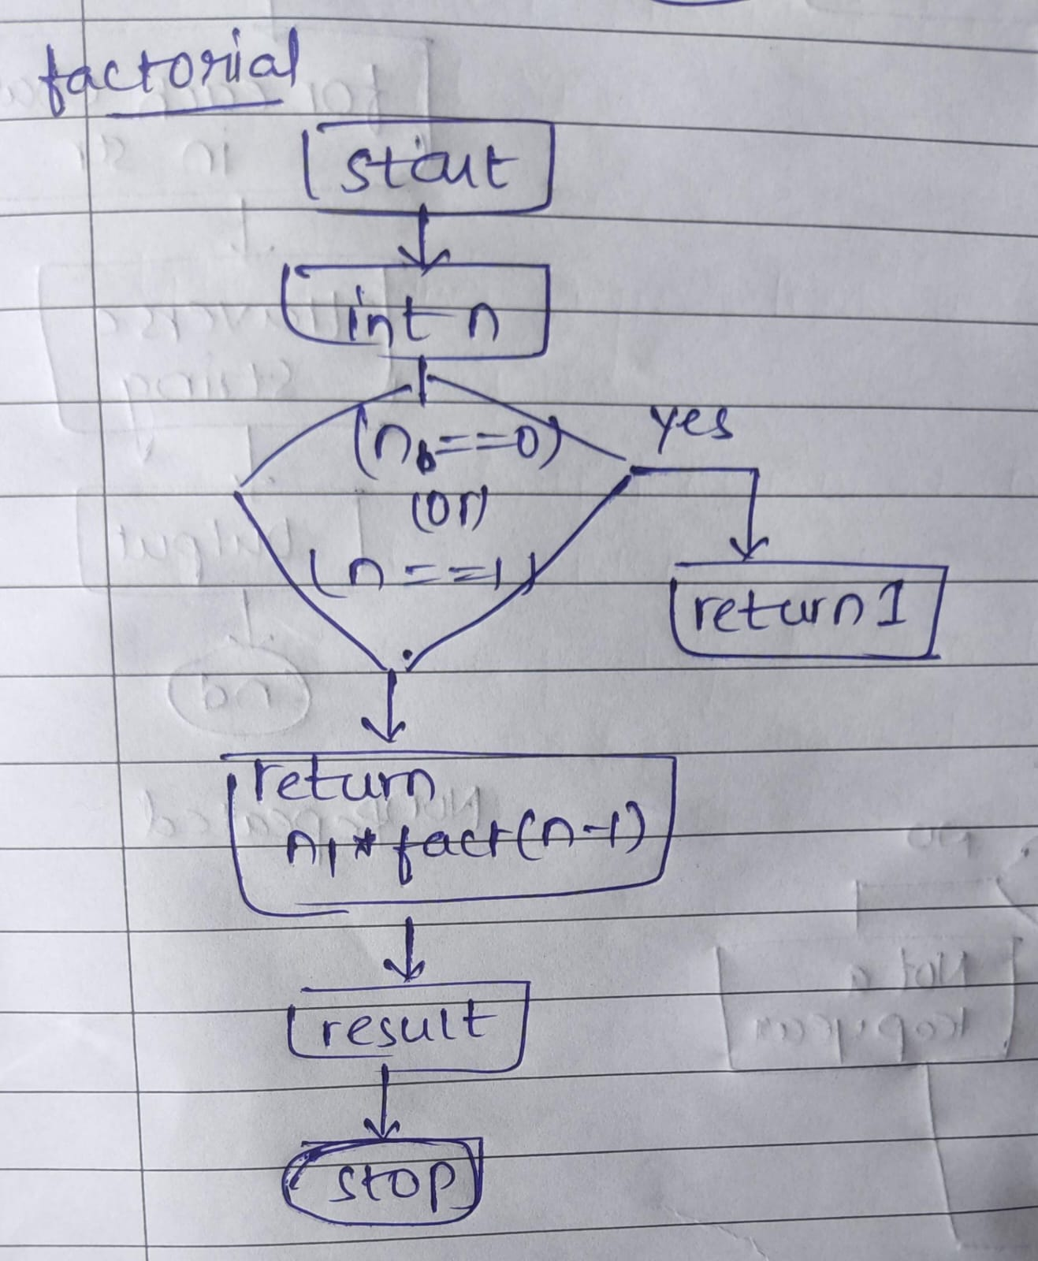

Time Complexity: O(n)
Space Complexity: O(n)

4. Fibonacci Series
Problem: Write a Java program to print the first n numbers in the Fibonacci series.
class Fibonacci {
static int fib(int n) {
if (n <= 1) {
return n;
}
return fib(n - 1) + fib(n - 2);
}

public static void main(String args[]) {
int n1 = 5;
int n2 = 8;
System.out.print("Fibonacci series up to " + n1 + ": ");
for (int i = 0; i < n1; i++) {
System.out.print(fib(i) + " ");
}

System.out.print("\nFibonacci series up to " + n2 + ": ");
for (int i = 0; i < n2; i++) {
System.out.print(fib(i) + " ");
}
}
}

C:\Users\saira\OneDrive\Documents\CDAC\ADS Module\Assignment1>java Fibonacci
Fibonacci series up to 5: 0 1 1 2 3
Fibonacci series up to 8: 0 1 1 2 3 5 8 13

Time Complexity:O(2^n)
Space Complexity: O(n)

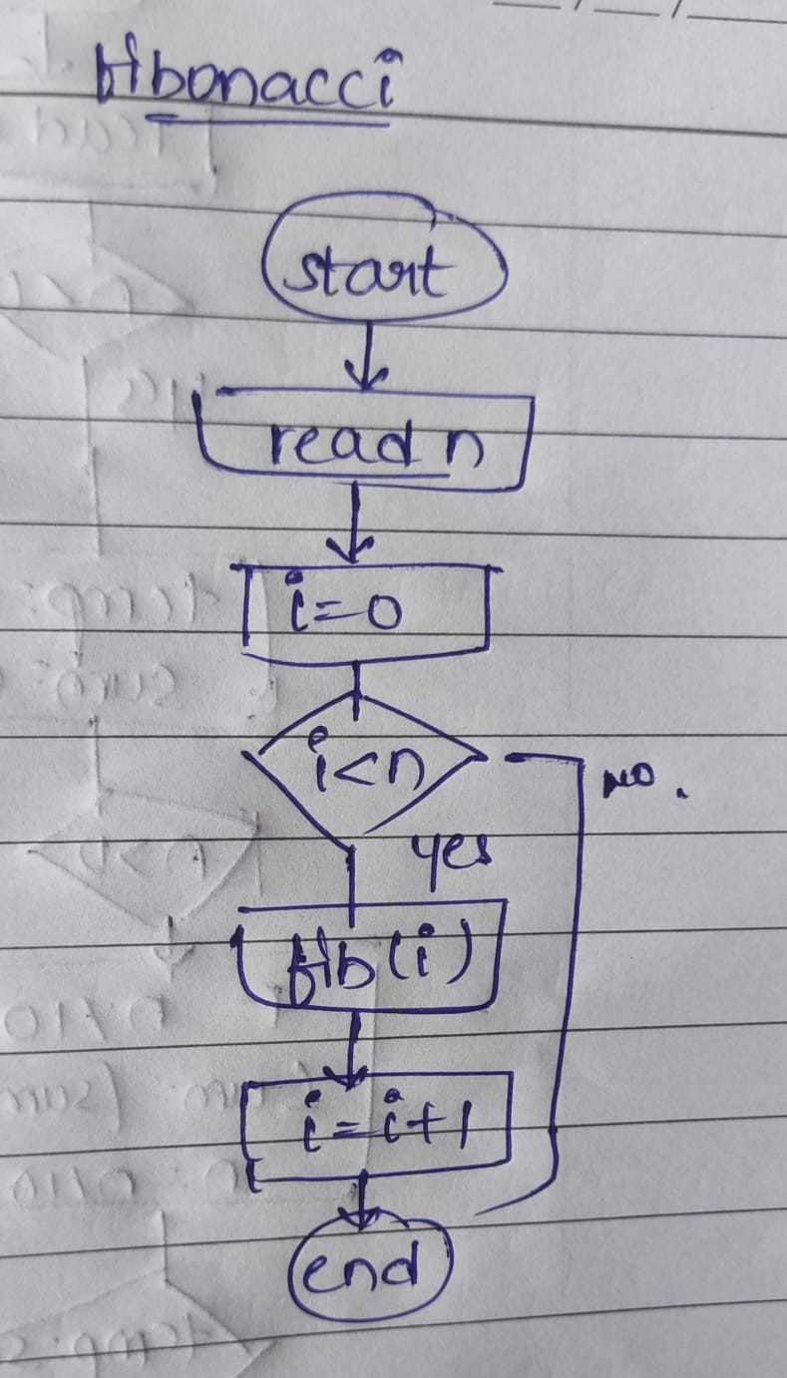

5. Find GCD
Problem: Write a Java program to find the Greatest Common Divisor (GCD) of two numbers.
class GCD{
public static int gcd(int a, int b){
if(b==0){
return a;
}
return gcd(b,a%b);
}

public static void main(String args[]){
System.out.println(gcd(54,24));
System.out.println(gcd(17,13));
}
}

C:\Users\saira\OneDrive\Documents\CDAC\ADS Module\Assignment1>java GCD
6
1
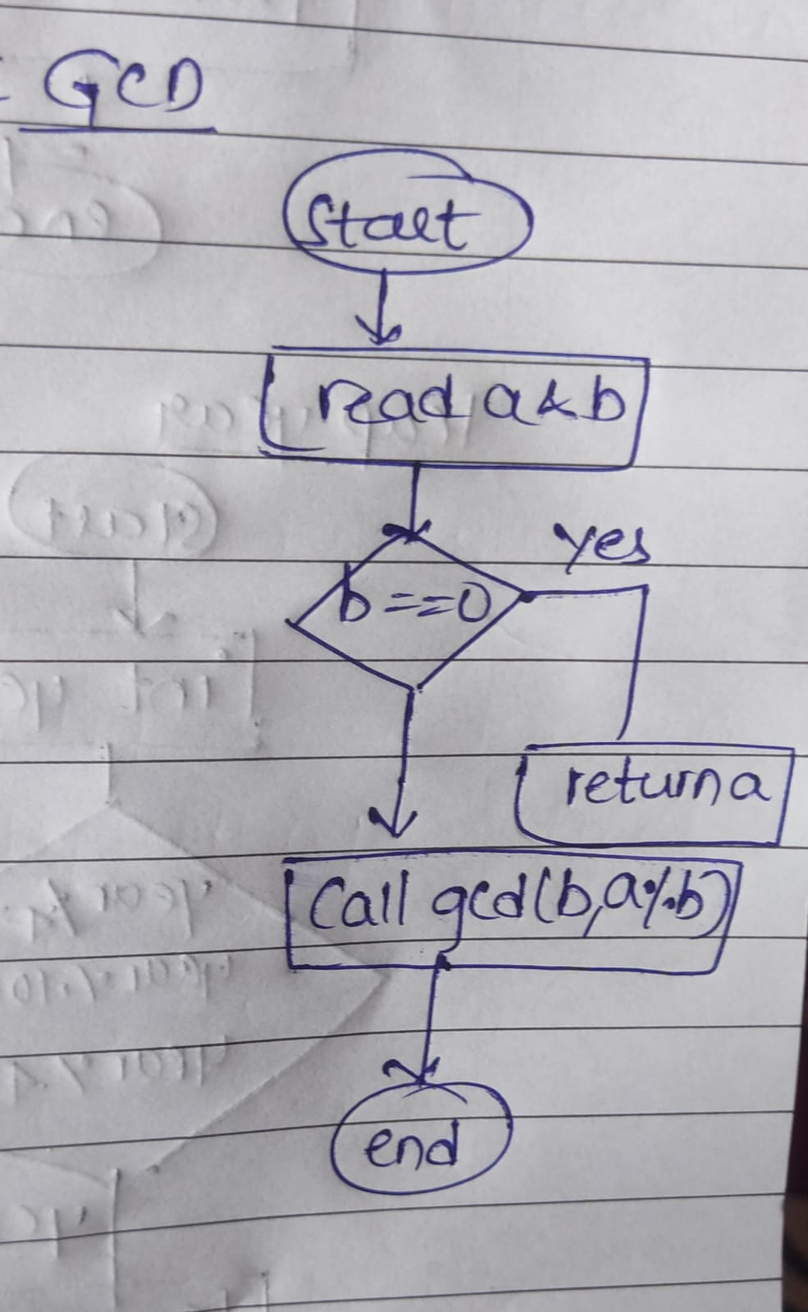

Time Complexity: O(log⁡(n))
Space Complexity: O(log⁡(n))

6. Find Square Root
Problem: Write a Java program to find the square root of a given number (using integer approximation).
class Squareroot{
public static int sqrt(int n){
if(n==0||n==1){
return n;
}
int start =1,end=n/2,ans=0;
while(start<=end){
int mid=(start+end)/2;
if(mid*mid==n)
return mid;

if(mid*mid <n){
start = mid+1;
ans=mid;
}
else{
end = mid-1;
}
}
return ans;
}
public static void main(String args[]){
System.out.println(sqrt(16));
System.out.println(sqrt(27));
}
}
C:\Users\saira\OneDrive\Documents\CDAC\ADS Module\Assignment1>java Squareroot
4
5
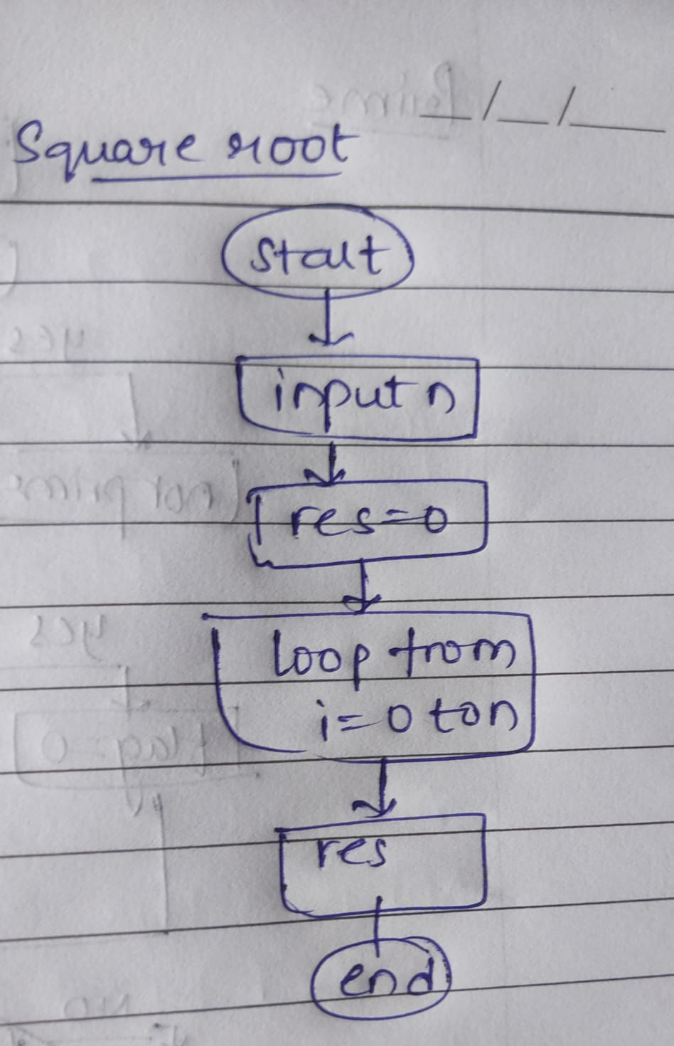
Time Complexity: O(log⁡(n))
Space Complexity: O(1)

7. Find Repeated Characters in a String
Problem: Write a Java program to find all repeated characters in a string.
class Duplicate {
public static void duplicate(String str) {
int count;
char[] string = str.toCharArray();

for (int i = 0; i < string.length; i++) {
count = 1;
if (string[i] != '\0') {
for (int j = i + 1; j < string.length; j++) {
if (string[i] == string[j]) {
count++;
string[j] = '\0';
}
}
if (count > 1) {
System.out.println(string[i]);
}
}
}
}

public static void main(String[] args) {
duplicate("programming");
duplicate("hello");
}
}

C:\Users\saira\OneDrive\Documents\CDAC\ADS Module\Assignment1>java Duplicate
r
g
m

l

Time Complexity:O(n^2)
Space Complexity: O(n)

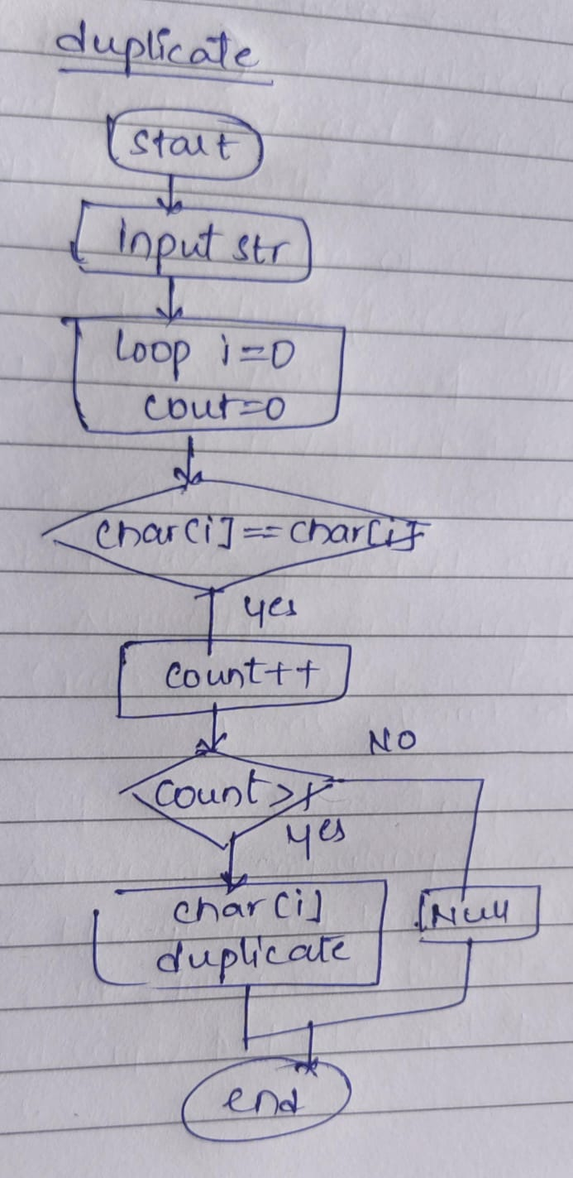
8. First Non-Repeated Character
Problem: Write a Java program to find the first non-repeated character in a string.
class Nonrepeat{
public static void Firstnonrepeat(String str){
boolean flag = true;
for(char i: str.toCharArray()){
if(str.indexOf(i)==str.lastIndexOf(i)){
System.out.println(i);
flag=false;
break;
}
}
if(flag==true){
System.out.println("null");
}
}
public static void main(String args[]){
Firstnonrepeat("stress");
Firstnonrepeat("aabbcc");
}
}
C:\Users\saira\OneDrive\Documents\CDAC\ADS Module\Assignment1>java Nonrepeat
t
null
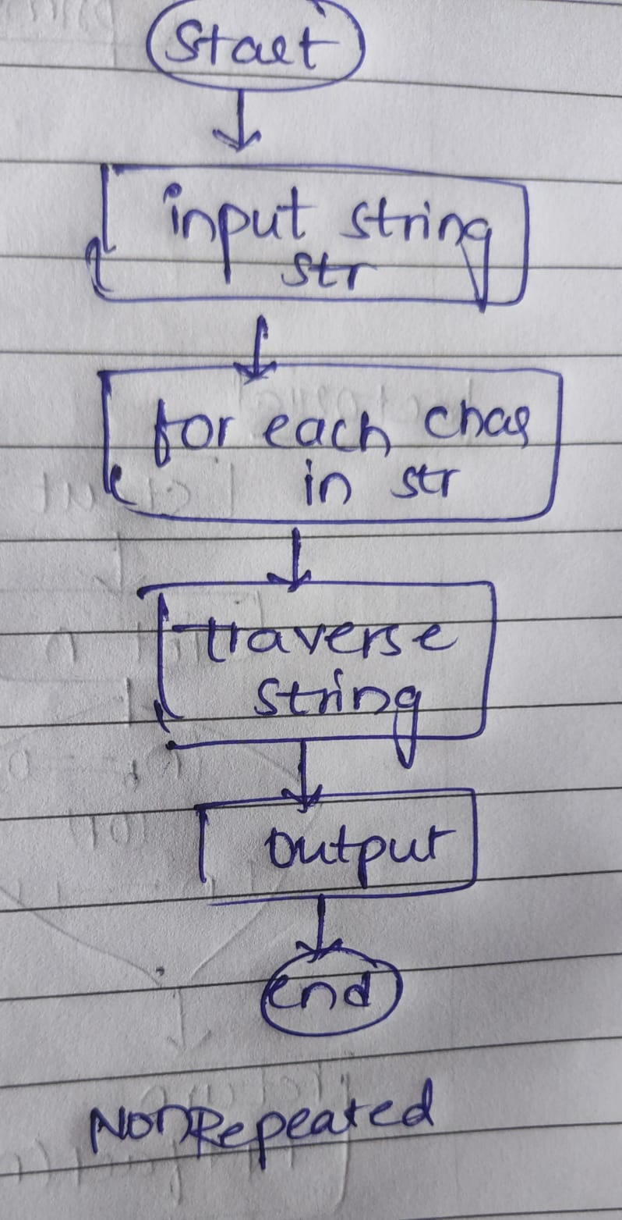
Time Complexity: O(n^2)
Space Complexity: O(1)

9. Integer Palindrome
Problem: Write a Java program to check if a given integer is a palindrome.
class Palindrome {
public static void palindrome(int n) {
int r, sum = 0, temp;
temp = n;
if (n < 0) {
System.out.println(n + " is not a palindrome");
return;
}
while (n > 0) {
r = n % 10;
sum = (sum * 10) + r;
n = n / 10;
}
if (temp == sum) {
System.out.println(temp + " is a palindrome");
} else {
System.out.println(temp + " is not a palindrome");
}
}

public static void main(String args[]) {
palindrome(121);
palindrome(-121);
}
}

C:\Users\saira\OneDrive\Documents\CDAC\ADS Module\Assignment1>java Palindrome
121 is a palindrome
-121 is not a palindrome

Time Complexity: O(log⁡(n))
Space Complexity: O(1)

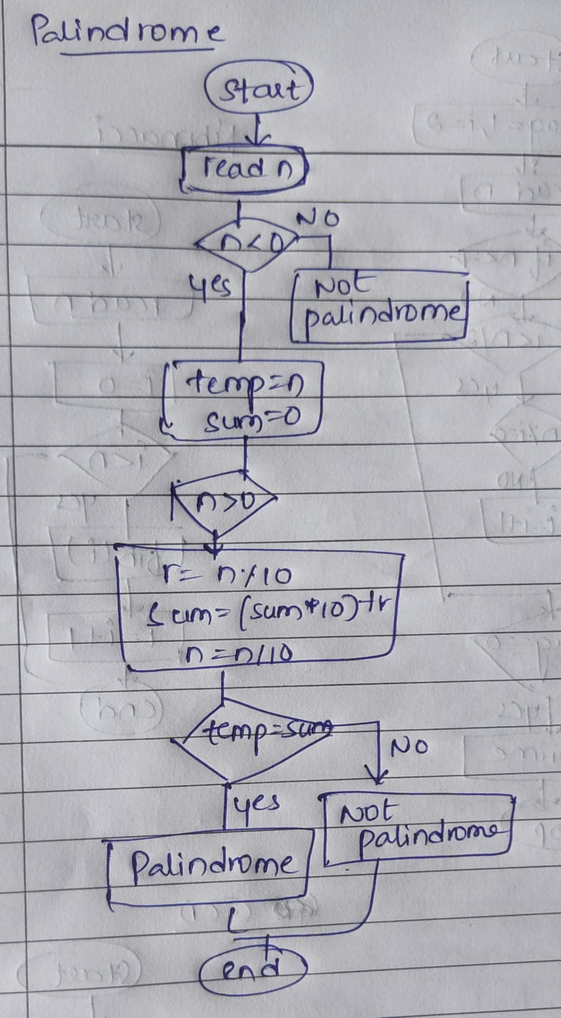
10. Leap Year
Problem: Write a Java program to check if a given year is a leap year.
public class Leapyear {
public static void Leap(int yr){
if((yr % 4 == 0 && yr%100!=0) || (yr%400 ==0)) {
System.out.println(yr + " is a leap year");
}
else {
System.out.println(yr + " is not a leap year");
}
}
public static void main(String[] args) {
Leap(2020);
Leap(1900);
}
}
C:\Users\saira\OneDrive\Documents\CDAC\ADS Module\Assignment1>java Leapyear
2020 is a leap year
1900 is not a leap year
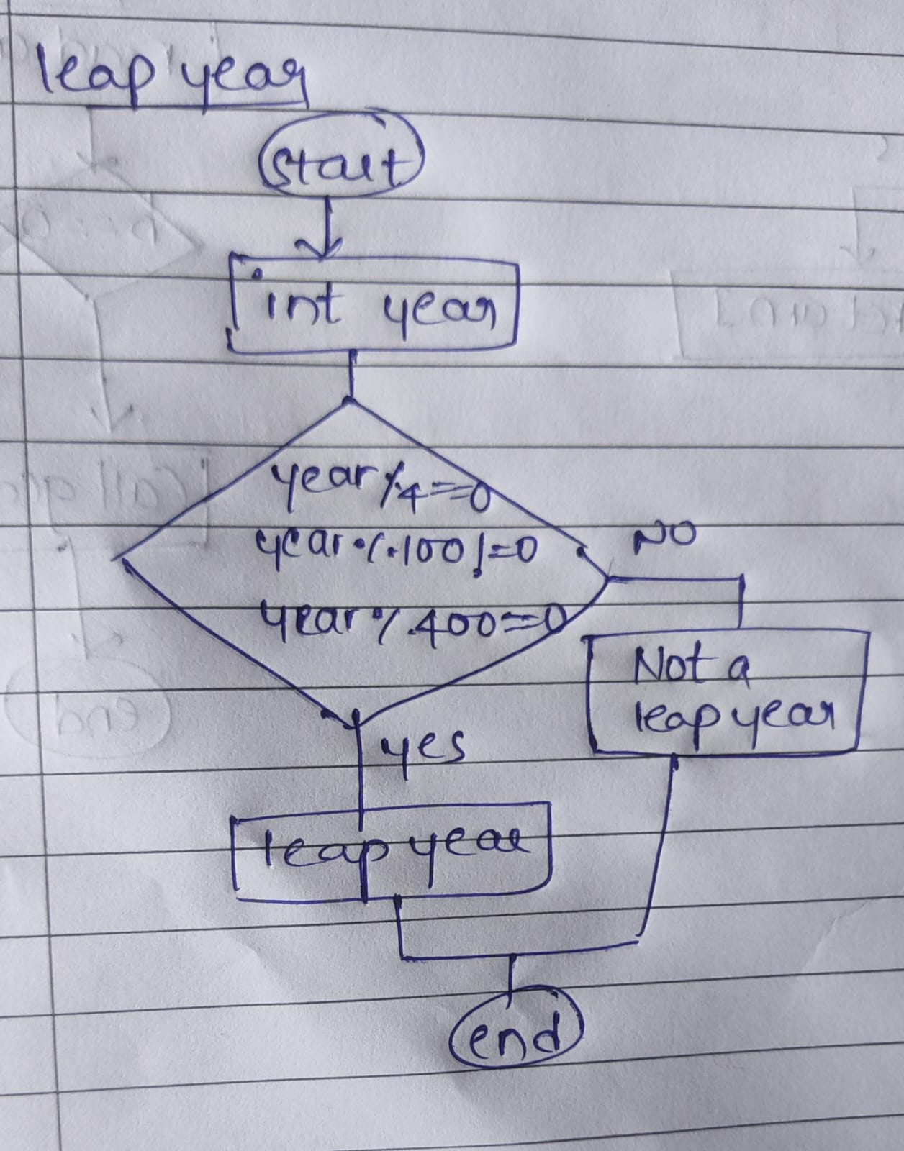
Time Complexity: O(1)
Space Complexity: O(1)

